**Lesson 4 Demo 2**

**Understanding Pods**



Steps to be followed:

1. Creating a single pod

**Step 1: Creating a single a pod**

1. Navigate to deployments folder:

***cd deployments***

1. Create a namespace using the command:

***kubectl create namespace twitter***



1. Create a Deployment file named singlepod.yaml:

***vi singlepod.yaml***



1. Add the following code in the **singlepod.yaml** file:

***apiVersion: v1***

***kind: Pod***

***metadata:***

***name: webserver***

***namespace: twitter***

***labels:***

***app: nginx***

***tier: front***

***version: v1***

***env: production***

***spec:***

***containers:***

***- name: nginx***

***image: nginx***

***ports:***

***- containerPort: 80***

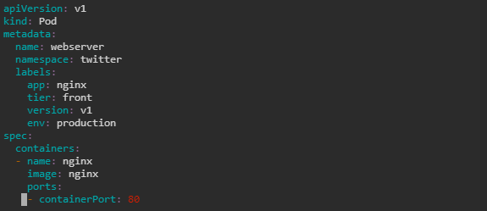

1. Type the following command to create the deployment:

***kubectl apply -f singlepod.yaml***



| **Note:** If an error shows up while executing Step 1.4, try executing the following command:  ***kubectl apply -f singlepod.yaml --validate=false*** |
| --- |

1. List the pods available in **twitter** namespaceusing the following command:

***kubectl get pods -n twitter***

